Optimization Task Brief
We will conduct two forms of optimization on this project:
- Object Pooling
- and Quadtree’s
Not only will these two methods make the project run more stably, it will also be able to run significantly smoother, especially under harsh conditions, such as increasing the number of critters to 1000.

Object Pooling
The method for object pooling is simple for this project. The reason object pooling will be effective is because the program is constantly unloading and loading the textures of critters as they collide with the destroyer. This puts the program under significant strain and makes it more unstable as more critters are collided with. The way to fix this is simple. All we have to do is stop the function of the critter when it collides with the destroyer, which will stop not only the movement of the critter, but also the drawing of it, essentially turning off the visibility of it.
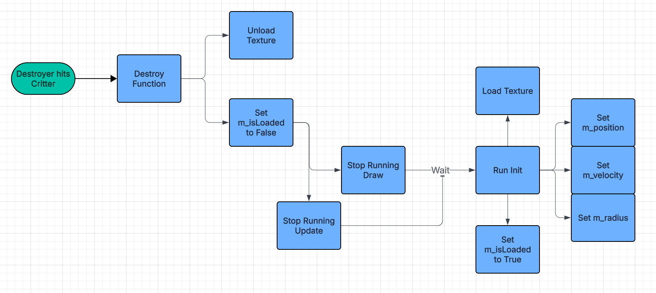
To do this, all we need to do is change the destroy function of the critter, removing the UnloadTexture method from it. We will leave the m_isLoaded bool inside the Destroy function, and since the other functions use this bool to tell when to run, we shouldn’t have to change any of those. Additionally, we can create an overloaded version of the Init function so that the critter can be drawn again without having to use the LoadTexture method. We can remove the const char* texture parameter, as we don’t need to load the texture anymore, and can remove the part where it sets the variable m_texture to LoadTexture(texture). Other than that, since it sets m_isLoaded back to true, we can keep it the same, and it should run a lot more stably now. Even though it doesn’t change the maximum framerate the project runs at, it doesn’t fluctuate as much between low and high framerates, increasing the average framerate.
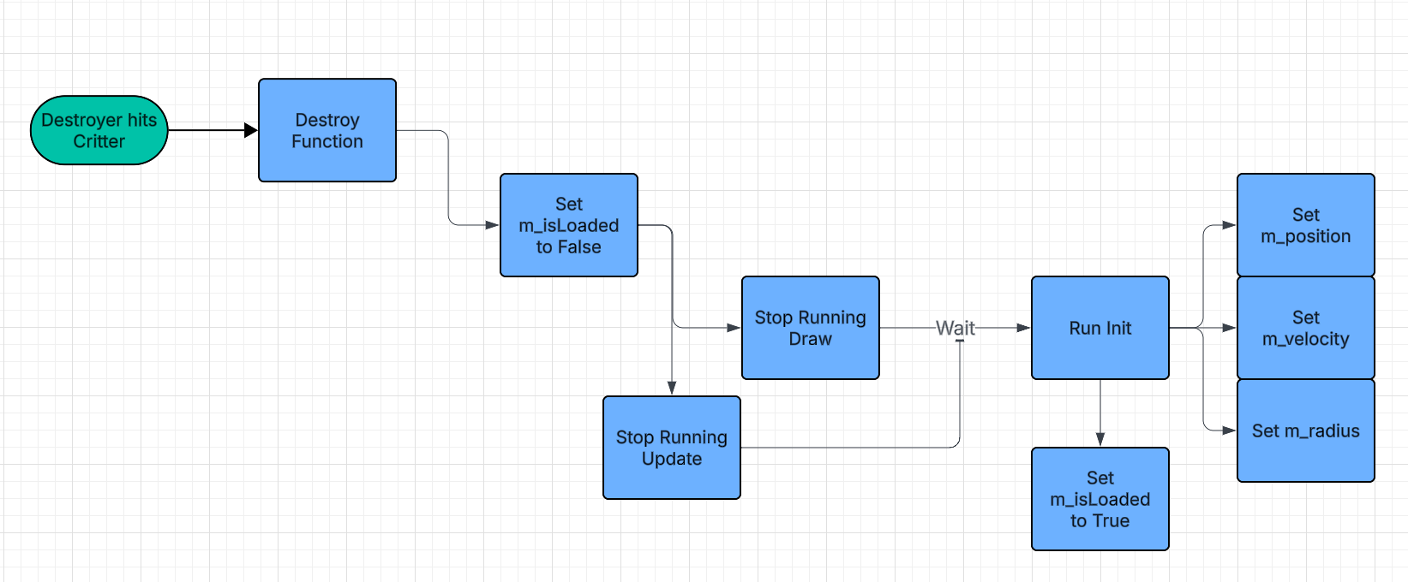

Quadtree
A quadtree will be quite effective in this project, as it will reduce the number of checks the program has to make drastically. Using the original code, it has to check 2500 times per frame, 50 times for 50 enemies. Using quadtrees, we will be able reduce this number significantly, and this will increase the fps of the project greatly.
To implement this, we will add a Quadtree class and header to the project, including functions such as:
- AABB: To see where critters fit in the Quadtree
- Insert: To put critters into the Quadtree
- Update: To update the data in the Quadtree when enemies move every frame
- Subdivision: To split the Quadtree into multiple branches and nodes
We will also move the collision checking from the main.cpp into a function in the Quadtree for simplicity.
There will need to be 4 Critter Pointer variables, one for each node on the base Quadtree. There will also be one Quadtree smart pointer for each of these nodes, used for subdivision if needed, otherwise left aside. The Quadtree constructor will need to gather data on the screen width and height of the program, as well as the centre point’s x and y, and the maximum number of critters per node. These will be put into their own variables.
The Insert function will have one parameter, being a Critter reference. Using the programs width, height, x and y, it will perform an AABB check on the Critter to see which node it belongs in. AABB will take in x, y, width and height values as well as a Critter reference and compare them to see where the critter fits in the Quadtree.
The update function will take in the original array of critters, as well as the size of the array. It will first clear out the nodes of the Quadtree, then it will re-insert all of the critters into the nodes. It will then check if any of the nodes need to subdivide. If they don’t, it will reset the smart pointers of the sub divided nodes. An overloaded version of Update will also be needed, to take in a Critter pointer vector instead of an array and size. The functionality will stay the same though.
Subdivision will take in an Enum to tell it what quadrant to subdivide, as well as the vector of Critters that are in that quadrant. It will then create a new Quadtree using the quadrants smart pointer, as well as the centre of the quadrant’s x and y values as well as the quadrants width and height, carrying over the same capacity. After creating this, you can run the update function on the subdivision quadtree and clear the quadrant’s vector, as the data is now in the sub quadtree.
Finally, you can check the collisions of the Critters in the quadtree. First, you can check if a subdivision has happened by checking if the quadrant vector is empty. If not, you can check the collisions normally. If so, you can run the check again in the subdivision.
Doing this will increase the fps of the program significantly on 50 enemies, and drastically on more than that, running smoothly on numbers greater than 1000.

